Our Covid 19 Procedures
We enforce a strict policy that anyone with any COVID-19 symptoms, or a positive test must not attend the clinic.
A triage is conducted via email or phone call.
A strict cleaning, sanitation and infection control protocol is adhered to.
All team members at BodyEvolve Clinic adhere to the social distancing guidelines issued by the Government.
The layout of the clinic and timing of appointments have been adapted to maintain social distancing and cleaning procedures.
Clinical team members will be wearing Personal Protective Equipment (PPE) for everyone's protection.
BodyEvolve Clinic is committed to ensuring that every measure is in place to minimise the risk of exposure to COVID-19, however we cannot guarantee there is no risk to you as a result of attending the clinic.

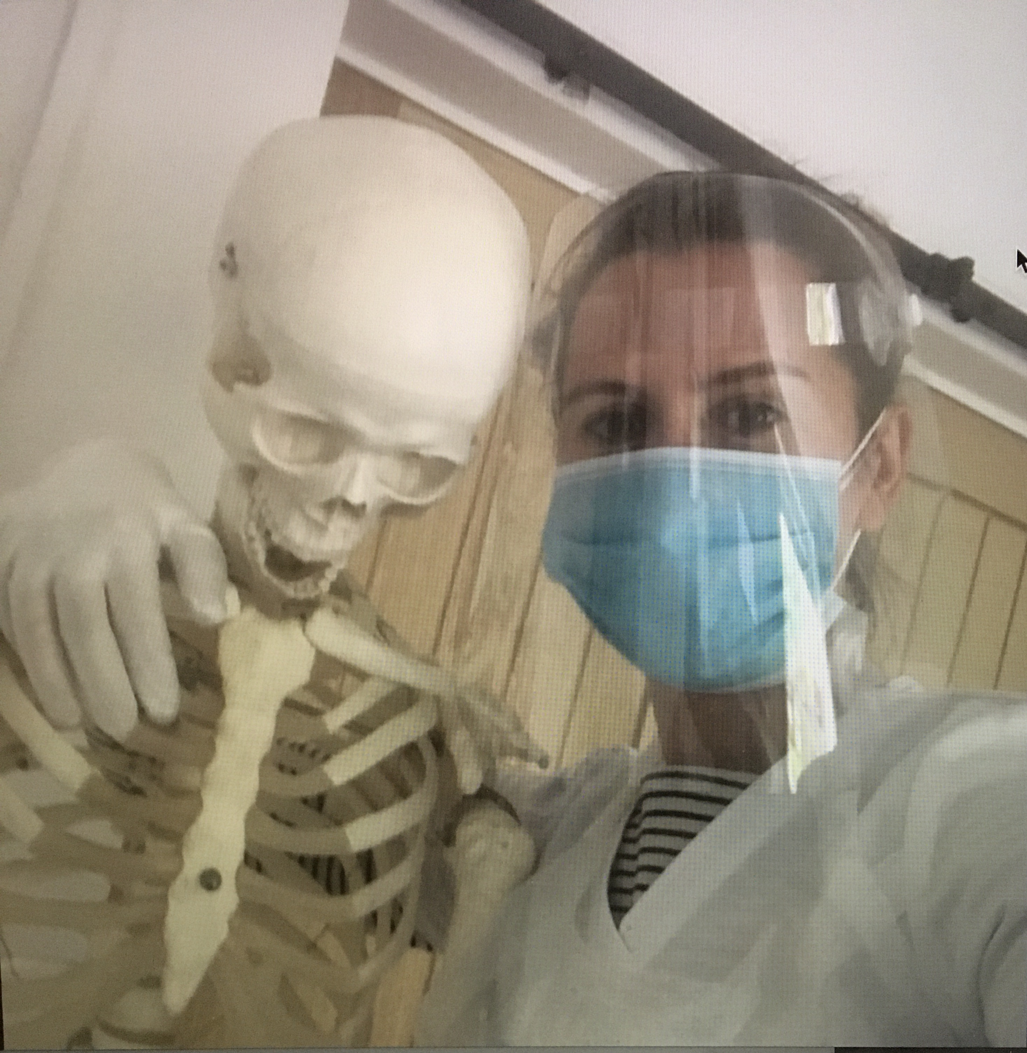

Eligibility for care
We are NOT accepting people with COVID-19 symptoms (or COVID-like symptoms), with positive tests, who are self-isolating due to exposure or living with someone with symptoms/ exposure.

We can accept patients from the "moderate risk” group, who have a long-term health condition or underlying medical conditions, as listed below:
- Chronic (long-term) respiratory diseases, such as asthma, chronic obstructive pulmonary disease, emphysema or bronchitis
- Chronic heart disease, such as heart failure
- Chronic kidney disease
Chronic liver disease, such as hepatitis
Chronic neurological conditions, such as Parkinson’s disease, motor neurone disease, multiple sclerosis, a learning disability or cerebral palsy
- Diabetes
- Conditions of the spleen, such as sickle cell disease or removal of the spleen
- A weakened immune system as the result of conditions such as HIV and AIDS, or medicines such as steroid tablets or chemotherapy.
- Seriously Obese, with a body mass index of 40 or above.

We are accepting people who are "clinically extremely vulnerable/high risk" as listed below,* with risk assessment:
*Have had an organ transplant
*are having chemotherapy or antibody treatment for cancer, including immunotherapy
*are having an intense course of radiotherapy (radical radiotherapy) for lung cancer
*are having targeted cancer treatments that can affect the immune system (such as protein kinase inhibitors or PARP inhibitors)
*have blood or bone marrow cancer (such as leukaemia, lymphoma or myeloma)
*have had a bone marrow or stem cell transplant in the past 6 months, or are still taking immunosuppressant medicine
*have been told by a doctor they you have a severe lung condition (such as cystic fibrosis, severe asthma or severe COPD)
*have a condition that means they have a very high risk of getting infections (such as SCID or sickle cell)
*are taking medicine that makes them much more likely to get infections (such as high doses of steroids)
*have a serious heart condition and are pregnant

